PRACTICAL DBMS
NAME: K.VIJAYALAKSHMI
REG.NO:192511189
COURSE CODE: CSA0503
COURSE NAME: DATABASE MANAGEMENT SYSTEMS
EXPERIMENT NO:1 DDL Commands – CREATE, ALTER, DROP
AIM:
To Create, Alter, Drop, Rename, Truncate using Data Definition Language (DDL) statements.
Description:
Data Definition Language (DDL) statements are used to define the database structure or schema.
DDL Commands: Create, Alter, Drop, Rename, Truncate
➢ CREATE - to create objects in the database
➢ ALTER - alters the structure of the database
➢ DROP - delete objects from the database
➢ TRUNCATE - remove all records from a table, including all spaces allocated for the records are
removed
➢ RENAME - rename an object
SYNTAX:
CREATE TABLE
CREATE TABLE table_name
(
column_name1 data_type,
column_name2 data_type,
column_name3 data_type,
....
);
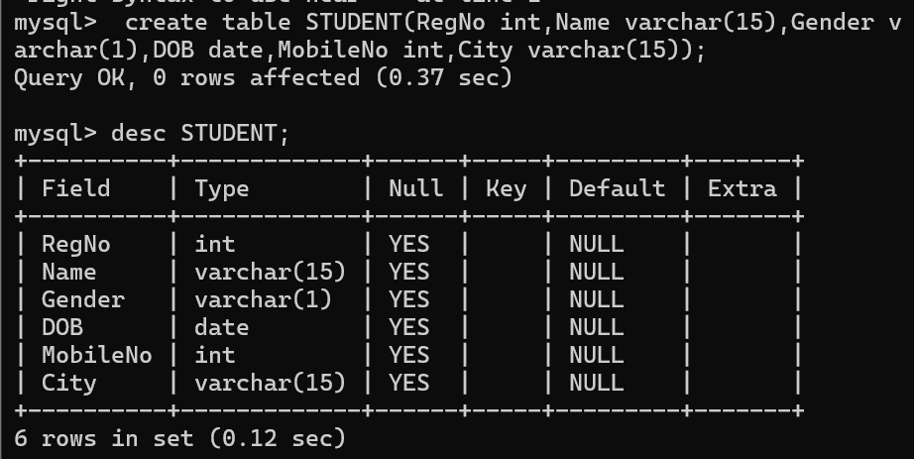
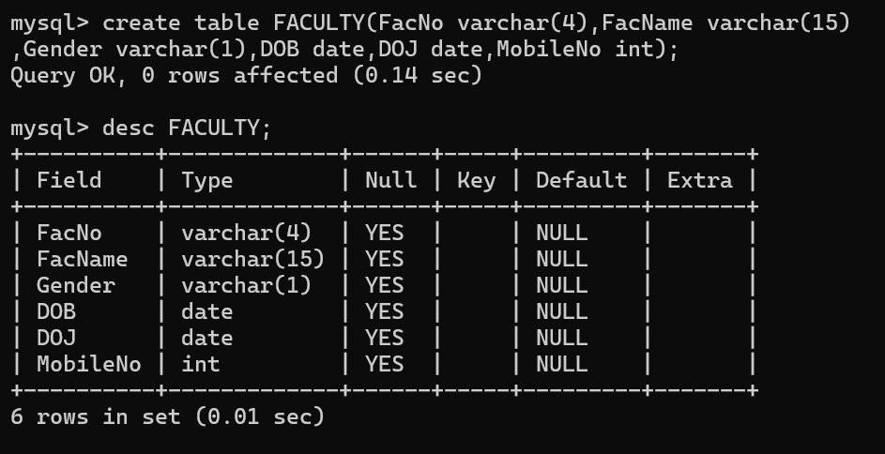
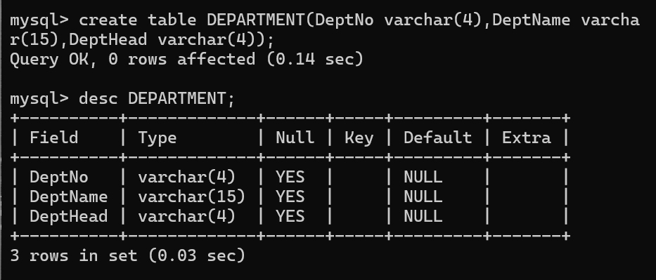
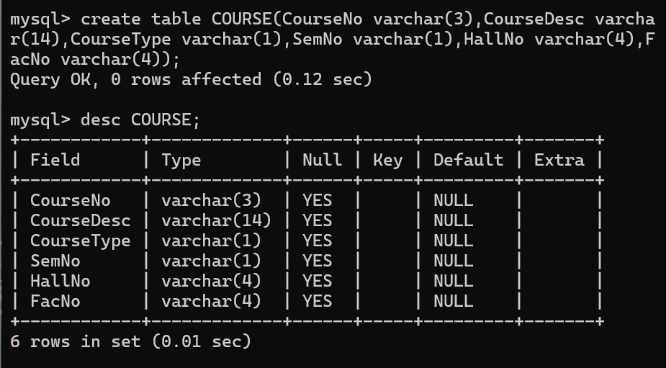

ALTER A TABLE
To add a column in a table
ALTER TABLE table_name
ADD column_namedatatype;

To delete a column in a table
ALTER TABLE table_name
DROP COLUMN column_name;
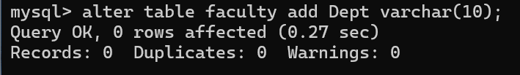
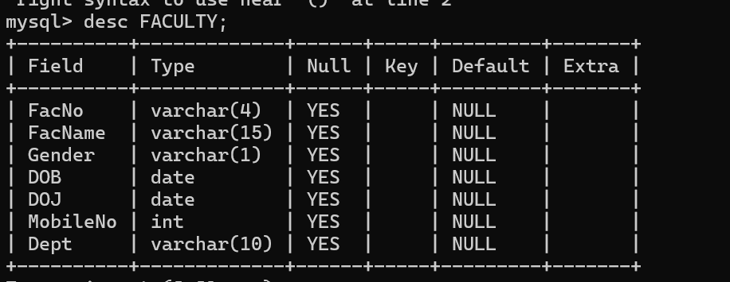

DROP TABLE
DROP TABLE table_name;
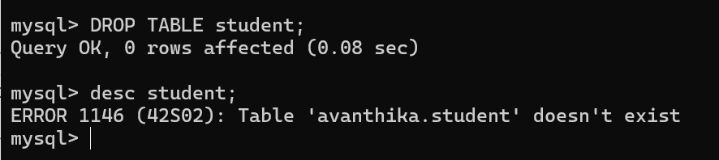

TRUNCATE TABLE
TRUNCATE TABLE table_name;

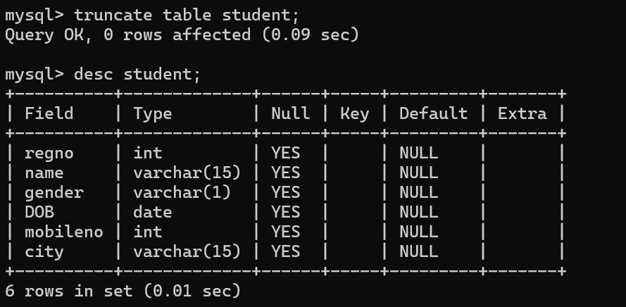
RESULT:
Tables are created, altered and modified using DDL commands.

EXPERIMENT NO:2 DDL Commands with Constraints – PRIMARY, FOREIGN KEY, UNIQUE, CHECK

AIM:
To add the constraints like primary key, foreign key, unique key and check using DDL commands.
Description:
PRIMARY KEY:
The PRIMARY KEY constraint uniquely identifies each record in a database table.
Primary keys must contain UNIQUE values, and cannot contain NULL values.
A table can have only one primary key, which may consist of single or multiple fields.
FOREIGN KEY:
➢ A FOREIGN KEY is a key used to link two tables together.
➢ A FOREIGN KEY is a field (or collection of fields) in one table that refers to the
PRIMARY KEY in another table.
➢ The table containing the foreign key is called the child table, and the table containing the candidate key is
called the referenced or parent table.
UNIQUE Constraint:
➢ The UNIQUE constraint ensures that all values in a column are different.
➢ Both the UNIQUE and PRIMARY KEY constraints provide a guarantee for uniqueness for a column
or set of columns.
➢ A PRIMARY KEY constraint automatically has a UNIQUE constraint.
➢ However, you can have many UNIQUE constraints per table, but only one PRIMARY KEY
constraint per table.
CHECK Constraint:
➢ The CHECK constraint is used to limit the value range that can be placed in a column
➢ If you define a CHECK constraint on a single column it allows only certain values for this column.
➢ If you define a CHECK constraint on a table it can limit the values in certain columns based on
values in other columns in the row.
PRIMARY:
ALTER TABLE table_name
ADD PRIMARY KEY(primary_key_column);
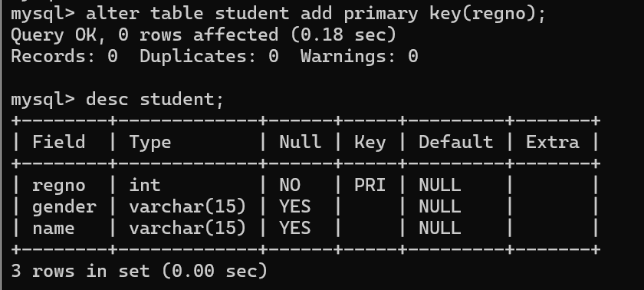
FOREIGN KEY:
ALTER TABLE table_name
ADD CONSTRAINT constraint_name
FOREIGN KEY foreign_key_name (columns)
REFERENCES parent_table(columns)
ON DELETE action
ON UPDATE action
UNIQUE:
CREATE TABLE table_1(
...
column_name_1 data_type,
...
UNIQUE(column_name_1)
);
CHECK
CREATE TABLE IF NOT EXISTS parts (
part_no VARCHAR(18) PRIMARY KEY,
description VARCHAR(40),
cost DECIMAL(10 , 2 ) NOT NULL CHECK(cost > 0), price DECIMAL (10,2) NOT
NULL
);

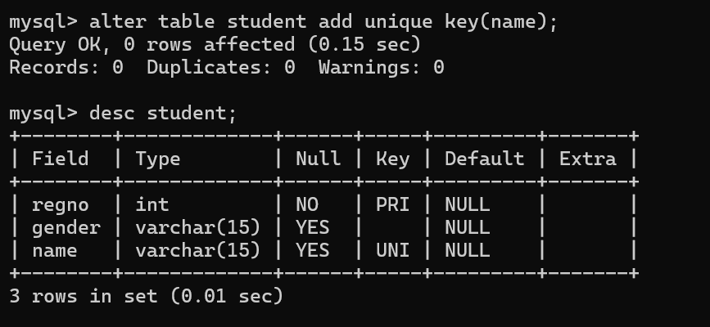
Result:
DDL Commands with Primary, Foreign, Unique, Check constraints are updated and verified.

EXPERIMENT NO:3 DML Commands – INSERT, SELECT
AIM:
To perform Data Manipulation Language (DML) Commands such as INSERT, SELECT in the table.
Description:
Data Manipulation Language (DML) statements are used for managing data within schema objects. DML
Commands: Insert, Select
➢ INSERT - insert data into a table
➢ SELECT - retrieve data from the a database
INSERT:
INSERT INTO table_name
VALUES (value1, value2, value3,...);
( or )
INSERT INTO table_name (column1, column2, column3,...)
VALUES (value1, value2, value3,...);
SELECT:
SELECT column_name(s)
FROM table_name;
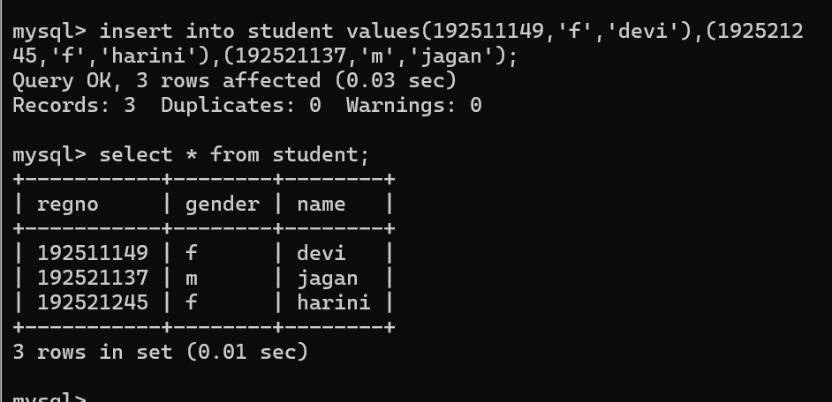

RESULT:
Data Manipulation Language (DML) Commands such as INSERT, SELECT are performed in the five tables.

EXPERIMENT NO: 4 DML Commands with Constraints –UPDATE, DELETE
AIM:
To perform Data Manipulation Language (DML) Commands such as UPDATE, DELETE in the table.
Description:
Data Manipulation Language (DML) statements are used for managing data within schema objects. DML
Commands: Update, Delete
➢ UPDATE - updates existing data within a table
➢ DELETE - deletes all records from a table, the space for the records remain
UPDATE:
UPDATE table_name
SET column1=value, column2=value2,...
WHERE some_column=some_value;
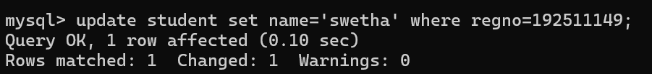

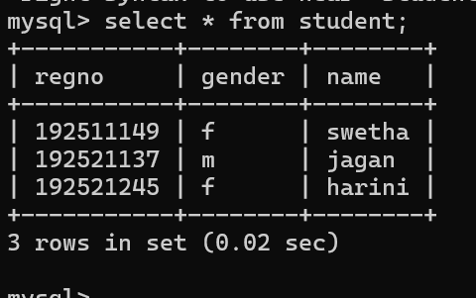

DELETE:
DELETE FROM table_name
WHERE some_column=some_value;

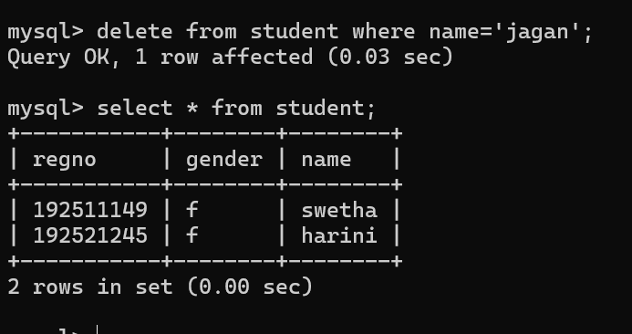

RESULT:
Data Manipulation Language (DML) Commands such as UPDATE, DELETE are performed in the five tables.

EXPERIMENT NO:5 SELECT with various clause – WHERE, pattern matching
AIM:
To view the records from the tables using SELECT commands with WHERE Clause and Pattern matching.
DESCRIPTION:
The SELECT statement allows you to get the data from tables. A table consists of rows and columns like a
spreadsheet. Often, you want to see a subset rows, a subset of columns, or a combination of two. The result of the
SELECT statement is called a result set that is a list of rows, each consisting of the same number of columns.
SELECT:
SELECTcolumn_1, column_2, ...
FROMtable_1
[INNER | LEFT |RIGHT] JOIN table_2 ON conditions
WHEREconditions
GROUP BY column_1
HAVING group_conditions
ORDER BY column_1
LIMIT offset, length;
The SELECT statement consists of several clauses as explained in the following list:
➢ SELECT followed by a list of comma-separated columns or an asterisk (*)
to indicate that you want to return all columns.
➢ FROM specifies the table or view where you want to query the data.
➢ JOIN gets related data from other tables based on specific join conditions.
➢ WHERE clause filters row in the result set.
➢ GROUP BY clause groups a set of rows into groups and applies aggregate
functions on each group.
➢ HAVING clause filters group based on groups defined by GROUP BY clause.
➢ ORDER BY clause specifies a list of columns for sorting.
➢ LIMIT constrains the number of returned rows.
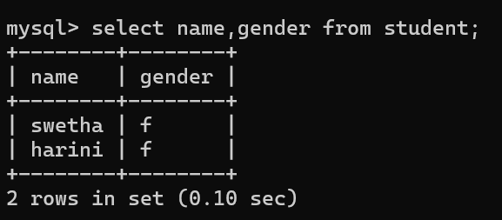
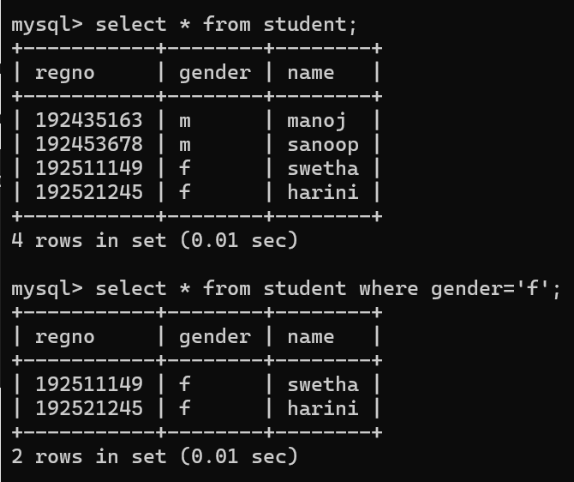
LIKE:
➢ The LIKE operator is commonly used to select data based on patterns. Using the LIKE operator in the right
way is essential to increase the query performance.
➢ The LIKE operator allows you to select data from a table based on a specified pattern. Therefore, the LIKE
operator is often used in the WHERE clause of the SELECT statement.
➢ MySQL provides two wildcard characters for using with the LIKE operator, the percentage % and
underscore _ .
➢ The percentage ( % ) wildcard allows you to match any string of zero or more characters.
➢ The underscore ( _ ) wildcard allows you to match any single character.

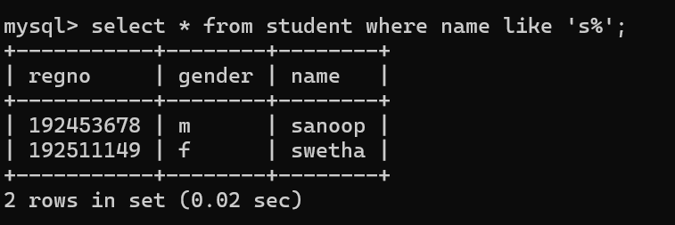
RESULT:
The records from the tables are displayed using SELECT commands with WHERE Clause and Pattern matching.

